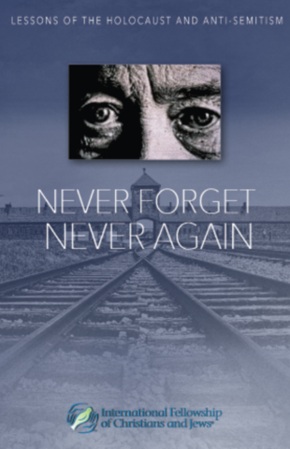

**The big issues – ‘Never Again’**

Table of Contents

1. Vocabulary for this lesson 3

2. Warm-up questions 4

3. Vocabulary (1) 5

4. Vocabulary (2) 6

5. Vocabulary (3) 7

6. Picture task 8

7. Film (1) 9

8. Film (2) 10

9. Multiple choice quiz 11

10. Lesson round up - Discussion 12

11. Lesson round up - Review vocabulary 13

Answers 14

## 1. Vocabulary for this lesson

An issue to discriminate a minority

Xenophobia a right an ideology

To challenge Never Again to contextualise

How do you say these words in your language?

Test your partner on the words

e.g. can you give me an example of a sentence with the word ‘discriminate’ in it?

e.g. When do you like to ‘challenge’ people?

## 2. Warm-up questions

What are the big issues facing Poland today?

What should all young people be taught?

Which are the best countries to live in at the moment?

Why those countries?

Is it good if everyone behaves and looks the same?

When do you like to look or behave different to others?

A universal language doesn’t exist – but do universal rights and morals?

Why is hatred bad?

Where does it come from?

Why is history important?

Why are there different versions of history?

Where does your version of history come from?

## 3. Vocabulary (1)

Match the definition with the word

movement symbol culture

fascism racism

1. something that stands for or suggests something else by reason of relationship, association, convention, or accidental resemblance
2. a tendency toward or actual exercise of strong autocratic or dictatorial control
3. the [systemic](https://www.merriam-webster.com/dictionary/systemic#h1) oppression of a racial group to the social, economic, and political advantage of another
4. a series of organized activities working toward an objective
5. The set of shared attitudes, values, goals, and practices that characterizes an institution or organization

## 4. Vocabulary (2)

Compete the table with the word forms

|  |  |  |  |
| --- | --- | --- | --- |
| noun | verb | adjective | adverb |
| culture  culturist | cultivate | cultural | __________ |
| symbol  symbolist  symbolism | ________ | symbolic | symbolically |
| occupant  ____________ | occupy | occupied  occupying |  |

Use the words to complete the sentences.

1. Our __________ is what makes us special – we are all __________ creatures.
2. Poland was __________ in 1939 by two ___________ forces – one from the east and one from the west.

## 5. Vocabulary (3)

Collocations and synonyms.

**xenophobia** – which collocations are correct

tackle do promote foul

**movement** - which synonyms are correct

organisation government flow organisation

**minority** - which collocations are correct

rights groups protest monitoring

**assault** - which synonyms are correct

takeover hit punch freedom

## 6. Picture task

Match the words with the pictures.

homophobia transphobia gynophobia

islamophobia monophobia heterophobia

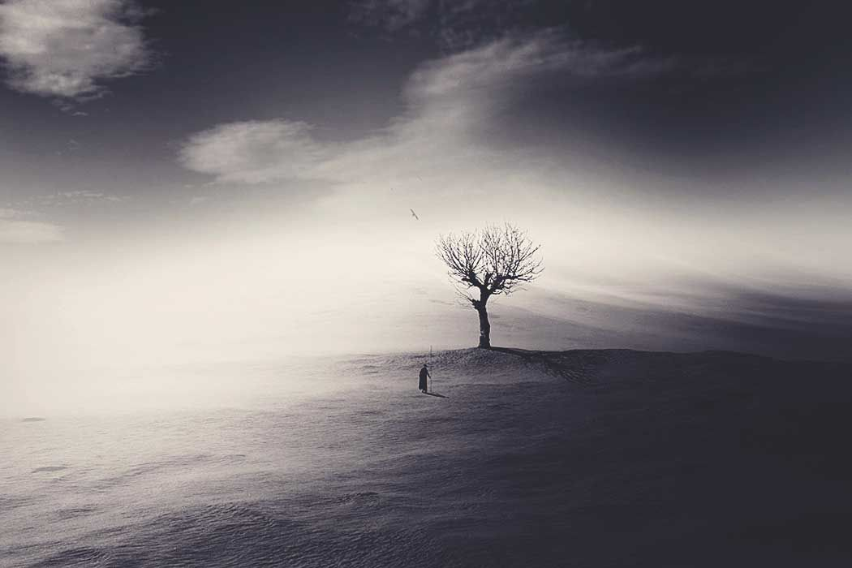

A 

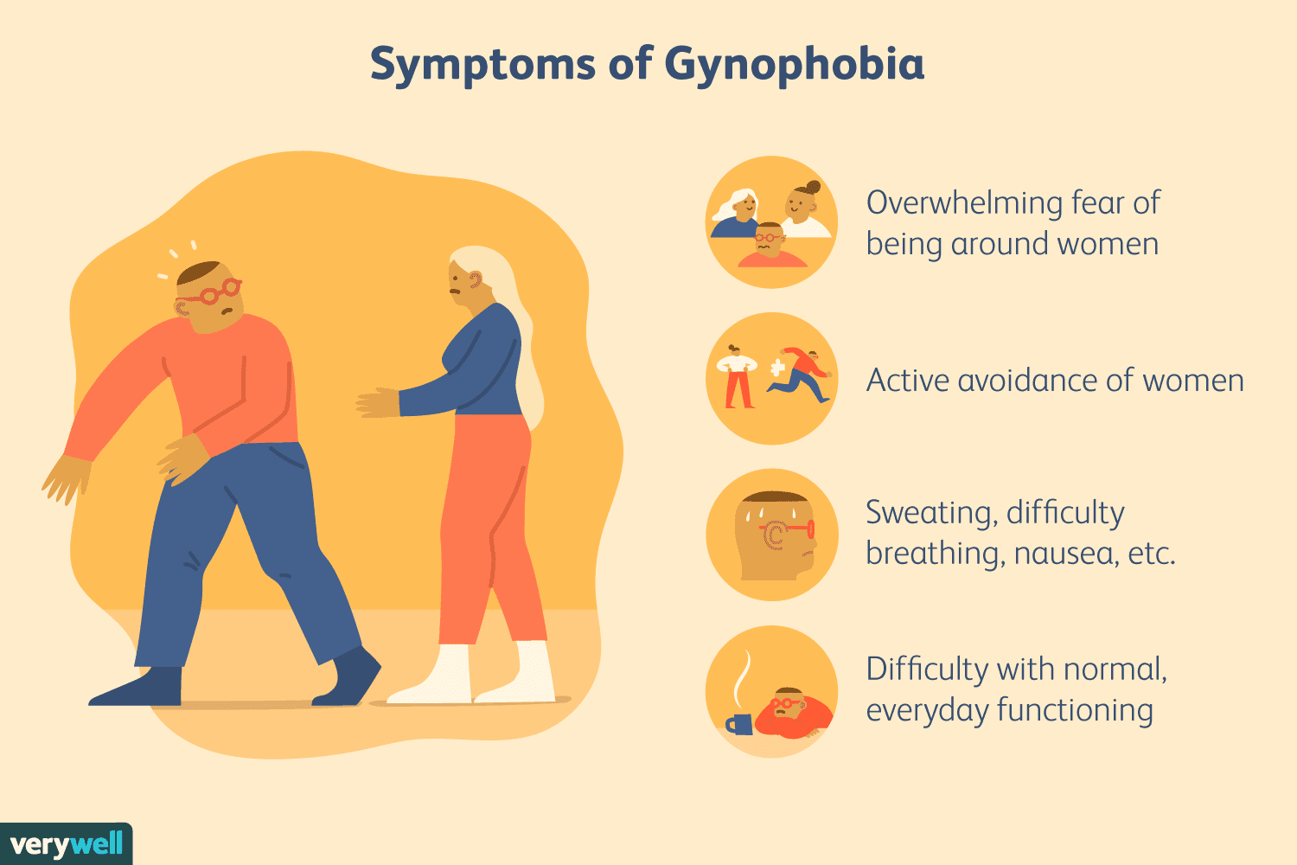

C

B

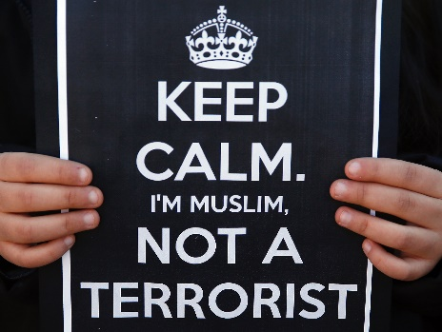

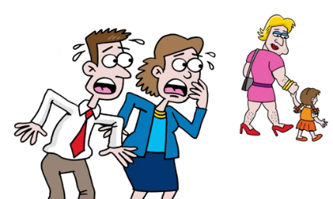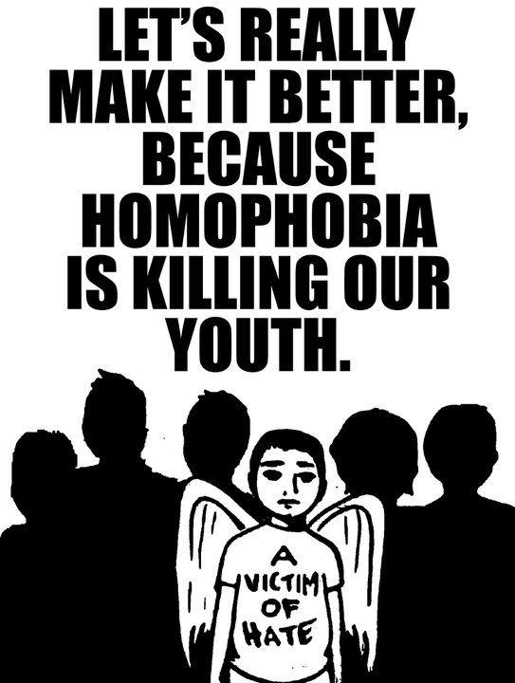

ED

FD

DD

What are the words for a fear of women and a fear of loneliness?

Do you have any phobias?

Who decides what is ‘normal’ nowadays?

What do the pictures make you think about tolerance and rights?

Are there any limits to what we should tolerate?

How does history influence our perception of the groups in the pictures?

## 7. Film (1)

**Task 1**

Do you know the answers to the questions? Work in groups of three and see if you can answer the questions.

* Who is the speaker?
* What does he say about ‘Never Again’?
* How much did he think about the meaning of the words ‘Never Again’?
* What historical events in Poland are mentioned?
* What is the meaning of ‘Never Again’ today?
* Which phobias are mentioned?

Watch the film, listen to the speaker, read the subtitles.

Try to find the answers to the questions.

**Task 2**

In the same groups of three, check your answers.

What did you find interesting in the film?

What did you already know?

What didn’t you know?

## 8. Film (2)

**Task 1**

Do you know the answers to the questions? Work in groups of three and see if you can answer the questions.

* Is Fascism a German and Italian ideology?
* Which other countries are mentioned?
* What does the speaker say about Poland?
* Who is Rudicki?
* What does the speaker say about cultural homogeneity?

Watch the film, listen to the speaker, read the subtitles.

Try to find the answers to the questions.

**Task 2**

In the same groups of three, check your answers.

What did you find interesting in the film?

What did you already know?

What didn’t you know?

## 9. Multiple choice quiz

**What does the rainbow flag generally promote?**

**Christianity nationalism tolerance**

**Which is *not* a symbol used by fascists nowadays?**

**rising Sun swastika Celtic Cross**

**Which event occurred first?**

**Warsaw Uprising liberation of Auschwitz bombing of Hiroshima**

**Which leader survived the Second World War?**

**Adolf Hitler Benito Mussolini General Franco**

**Which word applies to fascism?**

**democratic autodidactic autocratic**

**’Freedom and Direct Democracy’ is a party in which country?**

**The UK Czechia Slovenia**

**‘Golden Dawn’ was a political party which had seats in the Parliament in…**

**Sofia Athens Tokyo**

## 10. Lesson round up - Discussion

1. What is your opinion of freedom and tolerance?
2. Should there be limits?
3. What are your definitions of responsibility and social responsibility?
4. What do you know about history from the years before 1800?
5. What lessons can we learn today from this period of history?
6. What do you know about pre-1939, 20th Century history in your country?
7. What are the most important lessons we can learn from this period?
8. How important have the last ten years been in your country?
9. Is the country in a better position now than ten years ago?
10. What are the biggest issues you worry about these days?
11. What is being done about those issues?

## 11. Lesson round up - Review vocabulary

1. Make a list of five words from the lesson.
2. Test your partner on the words.
3. Choose two key words from the lesson
4. Which one point will you take away from the lesson?

## Answers

1.

problemy wyróżnić się mniejszość

ksenofobia prawo ideologia

wyzwać nigdy więcej w celu kontekstualizacji

3.

movement 4 symbol 1 culture 5 fascism 2 racism 3

4.

Compete the table with the word forms

|  |  |  |  |
| --- | --- | --- | --- |
| noun | verb | adjective | adverb |
| culture  culturist | cultivate | cultural | culturally |
| symbol  symbolist  symbolism | symbolise | symbolic | symbolically |
| occupant  occupation | occupy | occupied  occupying |  |

Use the words to complete the sentences.

1. Our culture is what makes us special – we are all cultural creatures.
2. Poland was occupied in 1939 by two occupying forces – one from the east and one from the west.

**5.**

Collocations and synonyms.

**Xenophobia**  tackle promote

**movement** organisation organisation

**minority** rights groups protest monitoring

**assault** hit punch

6.

Homophobia f transphobia e gynophobia a Islamophobia d monophobia b heterophobia c

9.

Tolerance rising sun Warsaw uprising autocratic Czechia Athens