Art and Fascism

## 1. What do you remember?

What do you remember from the lesson? In the box / in your notebook, write ten words that you connect with the lesson. They can be nouns, adjectives, names, countries, verbs…anything you like, as long as they are connected to the lesson.

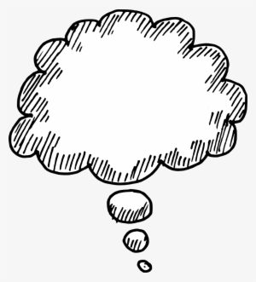

## 2. Before you watch the film

Before you watch the film, answer the three questions;

1. What is the title of the film?
2. Who is the person giving the lecture?
3. How long is the film?

## 3. Note taking

Watch the films. Note down the main ideas, names, themes in the film. An example is given here.

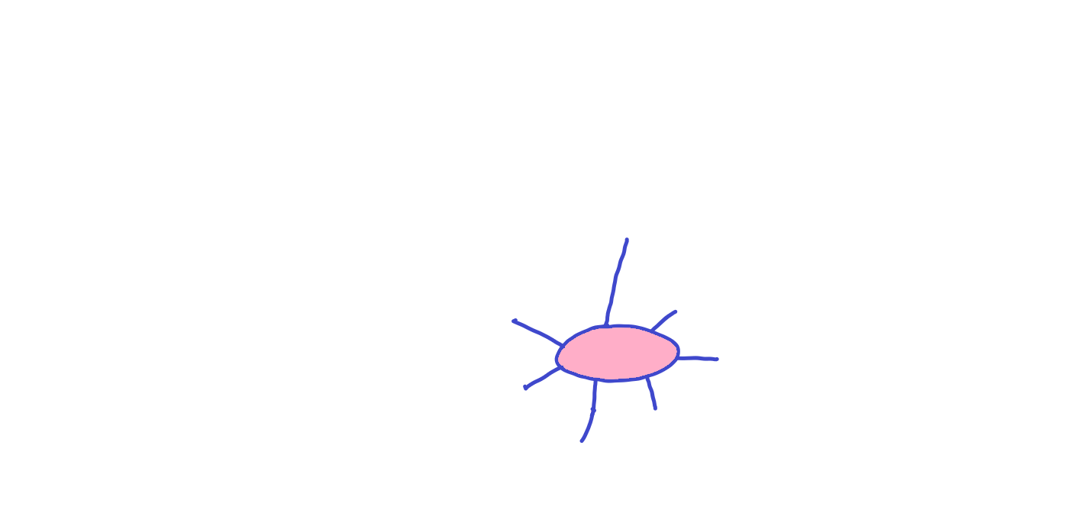

Destruction of Art

Different visions of the future

Writers fascism doesn’t like

Politicians and art these days

Those who oppose destruction of art

Italian Futurists and their art

Freedom and its relationship to art

Art and Fascism

## 4. Writing task

Detail the main idea that comes to you from the film. Explain it in a clear, engaging way. Here is an example. Use the notes from task 3 if you wish.

**Art and Fascism**

Art and its expression through various forms have been an integral part of human history since the earliest use of words and images to represent ideas and concepts. At certain times, the shadow of fascism has loomed large, with its deep-rooted history and enduring ideologies. Historically, fascism has employed force and oppression as tools to enforce its societal order, dictating how individuals should live their lives.

While the initial focus of fascism seemed to revolve around racial supremacy, a closer examination reveals a broader hostility towards any group perceived to deviate from the established norms. Present-day observations reveal a worrisome trend of art and cultural expressions coming under attack from far-right factions and politicians associated with such ideologies. This antagonism is evident in the targeted hostility towards writers, theatre performances, and artistic creations, signalling a concerning reality that demands our attention and vigilance.

In the face of these developments, it becomes increasingly clear that warning signs of oppression and censorship have emerged in the contemporary cultural landscape. The pervasive influence of far-right ideas and their impact on art and freedom of expression cannot be disregarded or underestimated. These indicators compel us to remain vigilant and actively address the challenges posed by such ideological incursions into the realm of creative expression.

## 5. Links

The film may have stimulated your interest on the wider issue of art, censorship, fascism and anti-fascism. Here are two links on the subject – one with a film to watch, and one with something to read.

Film: [(33) "Degenerate Art" in Nazi Germany - YouTube](https://www.youtube.com/watch?v=--E0g_s7Fi8)

Reading : [Umberto Eco Makes a List of the 14 Common Features of Fascism | Open Culture](https://www.openculture.com/2016/11/umberto-eco-makes-a-list-of-the-14-common-features-of-fascism.html)

## 6. Further investigation

You may wish to look further into the subjects, themes and name mentioned in the films. Google, YouTube and Wikipedia are three basic tools to make use of.

Try them with the following key words

Italian Futurists Futurist manifesto

Nazi Germany censorship Bruno Schulz

Pre-war Germany decadence anti-fascist art

Research is always better conducted when you have some idea of what you are looking for. Make a list of key words from the lesson and film and use them to conduct some online investigations of your own.