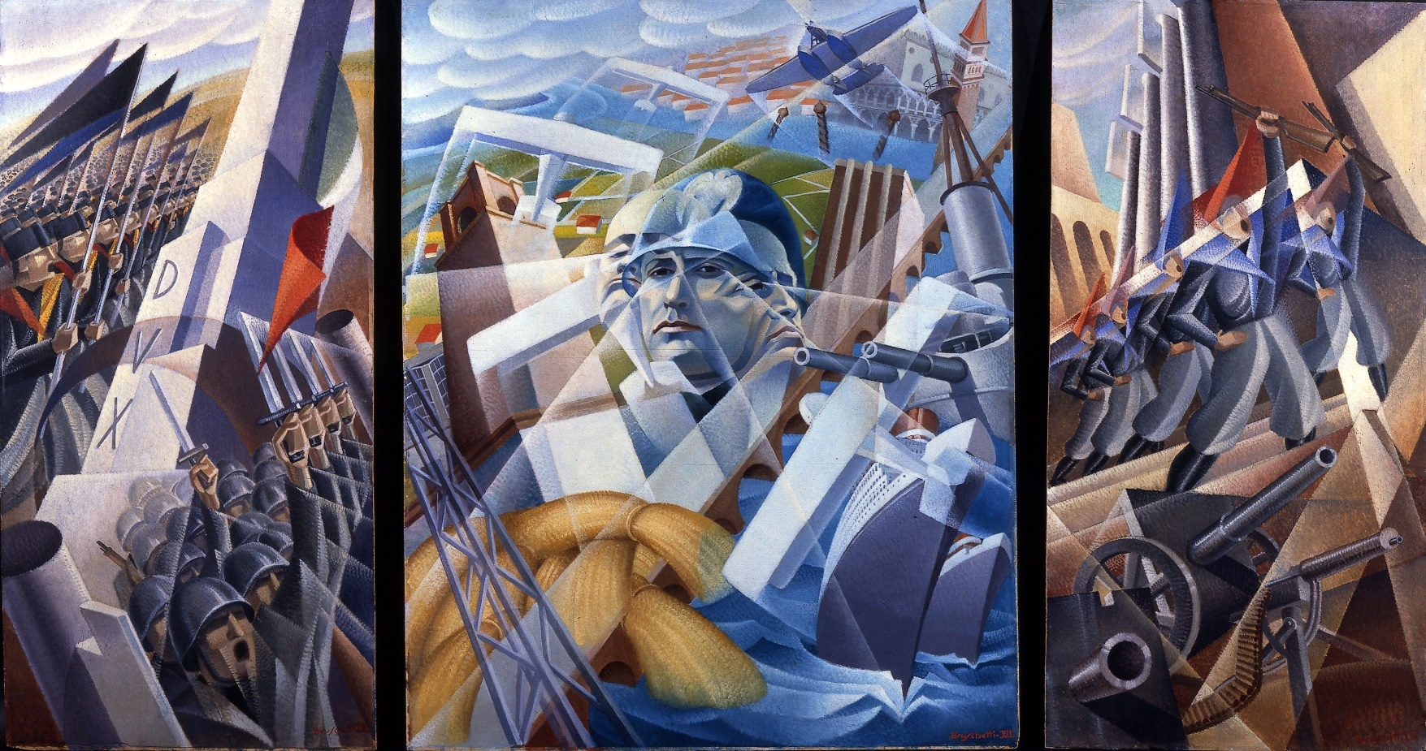
Art and Fascism

The Nazis condemned modern and avant-garde art as "degenerate," viewing it as a threat to traditional German values. This led to the confiscation and destruction of thousands of pieces of art, and the banning of certain artists and art movements. This suppression of artistic expression exemplifies the powerful and often destructive relationship between art and fascist ideology.

Table of Contents
1. Vocabulary for this lesson 3
2. Warm-up questions 4
3. Vocabulary (1) 5
4. Vocabulary (2) 6
5. Vocabulary (3) 7
6. Picture task 8
7. Film (1) 9
8. Film (2) 10
9. Film (3) 11
10. Quiz 12
11. Lesson round up - Discussion 13
12. Lesson round up - Review vocabulary 14
Answers 15

1. Vocabulary for this lesson

artist author work of art bonfire
landscape censorship decadence composition
insult affront ideological degenerate
publication government future ideal
hatred tragic burn denazification

How do you say these words in your language?
Test your partner on the words
e.g. can you give me an example of a sentence with the word ‘decadence in it?
e.g. ‘decadence. You can almost taste the decadence in the air of that once-thriving city, now nothing but overgrown ruins and faded opulence’.

2. Warm-up questions

What do you know about art from 1900-1945?
Futurism was a movement in art in this period. What sort of future did it suggest?
Have you heard of the following artists: Picasso, Dali, Natalia Goncharova, Alessandro Bruschetti or Max Ernst?
What do you know about art under Nazism and Fascism?
Are artists free people in your opinion?
Is art censored in some way in your country?
Have you heard about any controversial music, theatre performances or books that the authorities disliked?
Should art provoke strong feelings?
Can censorship sometimes be necessary?
Which books in your opinion should be banned or have very limited circulation?

3. Vocabulary (1)

Match the definition with the word

degenerate censor oppression
affront work of art bonfire

1. To suppress or restrict what can be seen, published, or spoken, typically because it is considered objectionable or harmful.
2. A creation (such as a painting, sculpture, or piece of music) that is considered to have value or aesthetic merit.
3. Prolonged cruel or unjust treatment or control, often by the government or another powerful group, leading to the feeling of being weighed down or burdened by severe and unjust force or authority.
4. A large outdoor fire, usually lit as a celebration or for disposing of waste.
5. An action or remark that causes outrage or offense.
6. Having lost the physical, mental, or moral qualities considered normal and desirable; showing evidence of decline.

4. Vocabulary (2)

Compete the table with the word forms
noun | verb | adjective | adverb
hatred  ___________ | ___________ | hated
Burner  ___________ | burn | ___________  burning | burningly
___________  futurism | futurize | ___________  future | ___________
ideal | ___________ | ___________  ideal | ___________  ideally

Use the words to complete the sentences.
- In order to stay interesting, the museum decided to …………….. its operations by implementing advanced technology and design.
- The …………. question in my head was a question I could not ask.
- ……….. only breeds more negativity and resentment, ultimately causing harm to both the hater and the hated.
- She had an …….. vision of what her future career would look like, and she worked tirelessly to make it a reality.

5. Vocabulary (3)

Collocations – which are correct?

publication – which collocations are correct
academic potato online legal
affront - which collocations are correct
deliberate pleasant personal unintentional
censor - which collocations are correct
content media crush information
tragic - which collocations are correct
truism loss event ending

Can you use the correct collocations in examples? Test yourself and your partner.

6. Picture task

Match the words with the pictures.
artist author work of art bonfire
landscape censorship decadence composition
insult affront ideological degenerate
publication government future ideal
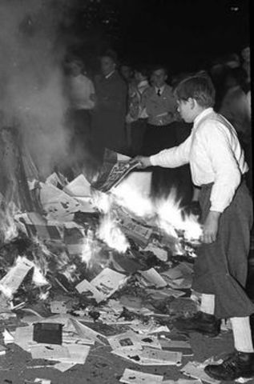
hatred tragic burn denazification
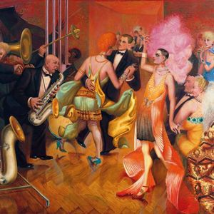
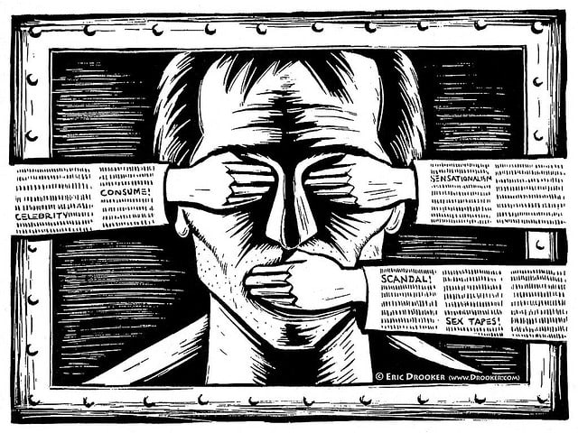
a
c
b

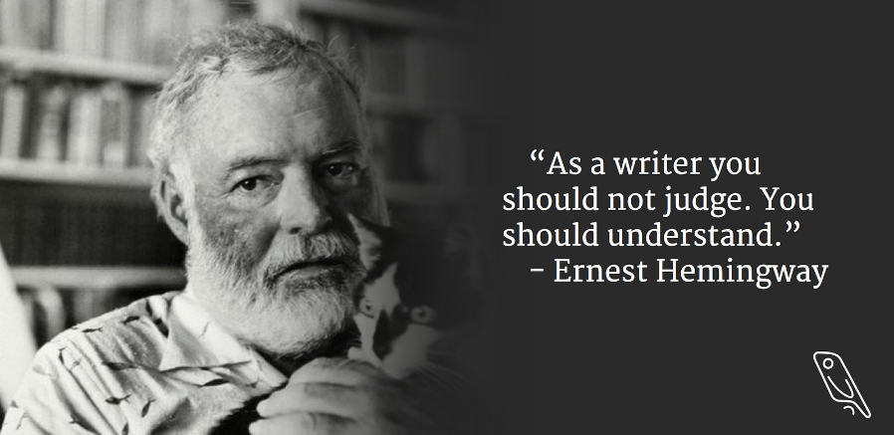
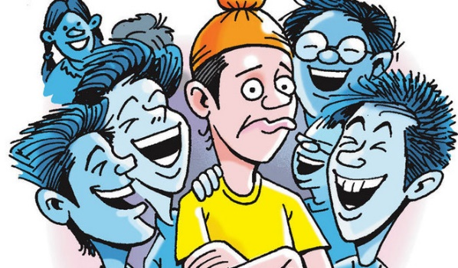
e
f
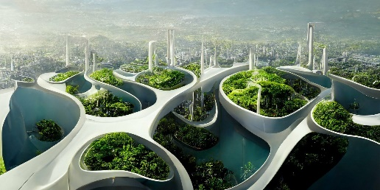
d

Which picture has the biggest impact on you?
How do you think the people in pictures ‘c’ and ‘e’ feel?
What do you think picture ‘d’ illustrates – something utopian or dystopian?
What do you think is the warning in picture ‘a’?
What can you deduce about the idea of freedom from the pictures?

7. Film (1)
From 5:00 to 6:30

Task 1
Decide if you think these statements are true or false? Work in groups of three.
- Italy was famous for art only in the Renaissance.
- Futurists glorified the state.
- Futurists were against war.
- Fascism never became popular in Italy.
- Fillipo Marinetti was an artist and politician.
- Fascism is a political order which promotes art.
Watch the film, listen to the speaker, read the subtitles.

Task 2
In the same groups of three, check your answers.
What did you find interesting in the film?
What did you already know?
What didn’t you know?

Film (2)
From 6:30 to 10:55

Task 1
Watch the film. Make a note of any cities and people that are mentioned. Check your answers with a partner.

Task 2
Watch the film again. Decide if these statements are true or false?
- The speaker talks about Warsaw.
- The Nazis organised the destruction of art and burning of books in 1933.
- There were only writers on the Nazis banned list.
- Both Jewish and American writers’ books were burned by the Nazis
- The art of Paul Klee was loved by the Nazi party officials.
- Nazis had a policy of teaching the appreciation of art in their education system.
Check your answers with your partner.

Task 3
What did you find interesting in the film?
What did you already know?
What didn’t you know?

Film (3)
From 12:57 to 14:34

Task 1 – warm-up
What do people in your country do to fight against racism?
Is racism an issue you hear much about?
Have you seen any campaigns in sport or in school?

Task 2
Watch the film. Make a note of any kinds of art or social activity that are mentioned (e.g. poetry, sport, ballet). Check your answers with a partner.

Task 3
Watch the film again. Which activities are mentioned?
- Poets against racism.
- Music against racism.
- The Red Book.
- The Brown Book.
- Social campaigns.
- Theatre productions.
- Facebook and Instagram campaigns
Check your answers with your partner.

Task 4
What did you find interesting in the film?
What did you already know?
What didn’t you know?

10. Quiz

Pablo Picasso painted the anti-fascist, anti-war painting Guernica – one of the greatest paintings of the 20th century. How much do you know about him? Do the quiz and find out.

1. What age was Pablo Picasso when he painted his first painting?
a) Five b) Nine c) Thirteen d) Fifteen
2. In which city did Picasso move to in 1900?
a) London b) Rome c) Paris d) Madrid
3. What was Picasso's first word, short for the Spanish word for pencil?
a) Pal b) Paz c) Piz d) Pio
4. How many works of art did Picasso create in his lifetime?
a) Over 10,000 b) Over 25,000 c) Over 50,000 d) Over 75,000
5. At what age did Picasso have his first art exhibition?
a) Nine b) Eleven c) Thirteen d) Fifteen
6. Picasso was once a suspect in the theft of which famous painting?
a) The Scream b) The Last Supper c) Guernica d) Mona Lisa
7. What was Picasso's reason for his father to give up art?
a) Lack of talent b) Poverty c) Illness d) Picasso's superior talent
8. How long is Picasso's full name?
a) 15 words b) 18 words c) 20 words d) 23 words
9. At what age did Picasso paint a bullfighter in his first ever painting?
a) Four b) Seven c) Nine d) Twelve
10. What art movement did Picasso co-found in the early 20th century?
a) Cubism b) Surrealism c) Dadaism d) Abstract Expressionism

11. Lesson round up - Discussion

- Why is art important?
- Is censorship ever right?
- What is a typical vision of the future?
- What is being done in your country to promote art?
- Would you ever join a protest in defence of art?
- Do you think the world has become a better place for art in the last 100 years?
- Before this lesson, did you hear much about politics and art?
- Does this lesson make you want to check out some artists and writers?
- Can extreme ideologies ever produce great art?
- Who are the most famous artists and writers in your country?
- Were / Are they political?

12. Lesson round up - Review vocabulary

- Make a list of five words from the lesson.
- Test your partner on the words.
- Choose two key words from the lesson
- Which one point will you take away from the lesson?

Answers

1.
artysta autor dzieło sztuki ognisko
krajobraz cenzura dekadencja kompozycja
obrażać zniewaga ideologiczny zdegenerowana
publikacja rząd przyszłość ideał
nienawiść tragiczny spalić denazyfikacja
3.
degenerate (6) censor (1) oppression (3)
affront (5) work of art (2) bonfire (4)

4.
Compete the table with the word forms
noun | verb | adjective | adverb
hatred  hater | hate | hated
Burner  brun | burn | burned  burning | burningly
future  futurism | futurize | futuristic  future | futuristically
ideal | idealise | idealistic  ideal | idealistically  ideally

Use the words to complete the sentences.
- In order to stay interesting, the museum decided to futurize its operations by implementing advanced technology and design.
- The burning question in my head was a question I could not ask.
- Hatred only breeds more negativity and resentment, ultimately causing harm to both the hater and the hated.
- She had an ideal vision of what her future career would look like, and she worked tirelessly to make it a reality.

- (incorrect are in bold)

publication – which collocations are correct
academic potato online legal
affront - which collocations are correct
deliberate pleasant personal unintentional
censor - which collocations are correct
content media crush information
tragic - which collocations are correct
truism loss event ending

6 many possible answers

7.
- Italy was famous for art only in the Renaissance false
- Futurists glorified the state. true
- Futurists were against war false
- Fascism never became popular in Italy. false
- Fillipo Marinetti was an artist and politician. true
- Fascism is a political order which promotes art. false

8.
- The speaker talks about Warsaw. false
- The Nazis organised the destruction of art and burning of books in 1933. true
- There were only writers on the Nazis banned list. false
- Both Jewish and American writers’ books were burned by the Nazis true
- The art of Paul Klee was loved by the Nazi party officials. false
- Nazis had a policy of teaching the appreciation of art in their education system. false

9.
mentioned
- Music against racism.
- The Brown Book.
- Theatre productions.

10.

1 B 2C 3C 4C 5B 6D 7D 8D 9C 10A

