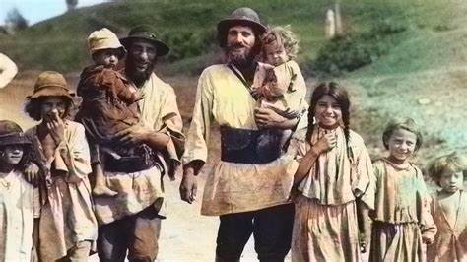
Roma Gypsies during Nazism

In most languages, “gypsy” is considered insulting and is rejected by Roma organizations. “Roma” is the right word to use for all related groups, regardless of their country of origin. – Amnesty International

Table of Contents
1. Vocabulary for this lesson 3
2. Warm-up questions 4
3. Vocabulary (1) 5
4. Vocabulary (2) 6
5. Vocabulary (3) 7
6. Picture task 8
7. Film (1) 9
8. Film (2) 10
9. Film (3) 11
10. Quiz 12
11. Lesson round up - Discussion 13
12. Lesson round up - Review vocabulary 14
Answers 15

1. Vocabulary for this lesson

Roma gypsy travellers tradition
stereotypes discrimination persecution nomadic
settlements heritage folklore culture
purge extermination ghetto survive

How do you say these words in your language?
Test your partner on the words
e.g. can you give me an example of a sentence with the word ‘persecution’ in it?
e.g. ‘persecution’. An example of persecution could be the historical mistreatment of Jews during the Holocaust or the discrimination and violence experienced by the Rohingya Muslims in Myanmar.

2. Warm-up questions

What do you know about the Roma?
What do you know about Nazism?
Do you know of any countries in the world Roma live?
How are Roma Gypsies viewed in the country you live in?
In which ways are Roma treated / viewed differently to other ethnic groups?
Why does one group of people tell another group how to behave?
Which groups of people are treated differently in your country?
How do the authorities and laws of your country view people who are different or don’t conform?
What protests or activities are you aware of in support of Roma gypsies to raise awareness of issues related to them?
What is the connection between Roma Gypsies, the state, fascism and human rights?

3. Vocabulary (1)

Match the definition with the word

desire slogan oppression
ideology minority folklore

- the smaller quantity or share
- conscious impulse toward something that promises enjoyment or satisfaction in its attainment
- traditional beliefs, stories, songs, and customs passed down within a specific culture
- a brief attention-getting phrase
- unjust or cruel exercise of authority or power
- a systematic body of concepts especially about human life or culture

4. Vocabulary (2)

Compete the table with the word forms
noun | verb | adjective | adverb
discrimination | ___________ | discriminatory
Stereotype | stereotype | ___________ | stereotypically
ghetto | ___________ | ghettoised  ghettoising
___________ | nomadize | ___________  nomadized | nomadically

Use a word from the table to complete the sentences.
- The …………… portrayal of certain groups as nomadically inclined has led to discriminatory treatment in some societies.
- The …………. policies of the past have ghettoized entire communities, perpetuating stereotypes and limiting opportunities for many individuals.
- Some people make stereotypical assumptions about ………….-inclined groups without understanding the cultural richness and diversity within these communities.
- It's important to challenge ………… attitudes and behaviors to create a more inclusive and equitable society for all.

5. Vocabulary (3)

Synonyms

purge – which word is not a synonym
cleanse purify clear hoard
settlement - which two words are not synonyms
colony conflict village agreement community
survivor - which two words are not synonyms
casualty victim fighter perisher
folklore - which two words are not synonyms
mythology physics legend tradition book

Can you use the correct collocations in examples? Test yourself and your partner.

6. Picture task

Match the words with the pictures.
Roma gypsy travellers tradition
stereotypes discrimination persecution nomadic
settlements heritage folklore culture
purge extermination ghetto survive

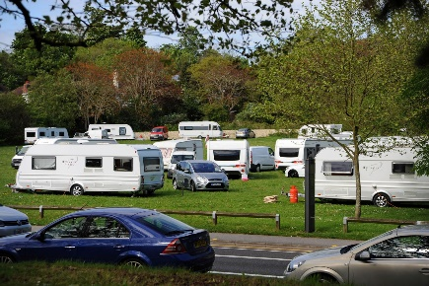
a
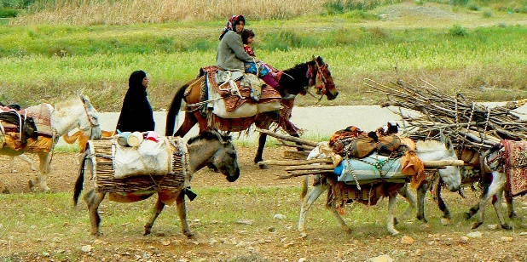
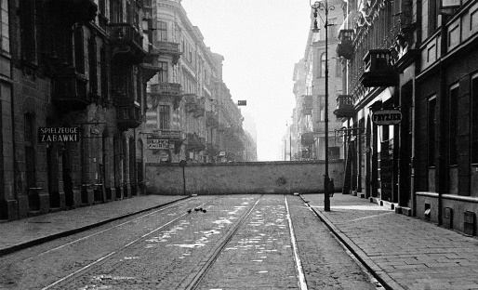
c
b

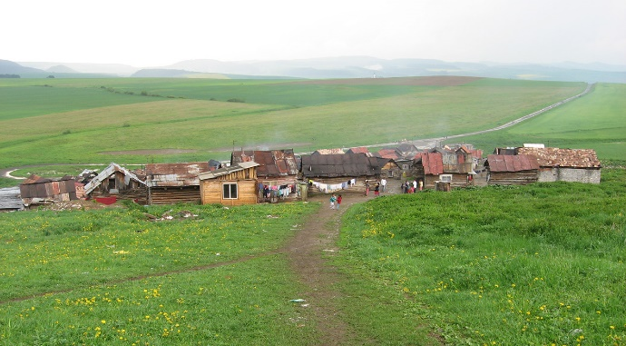
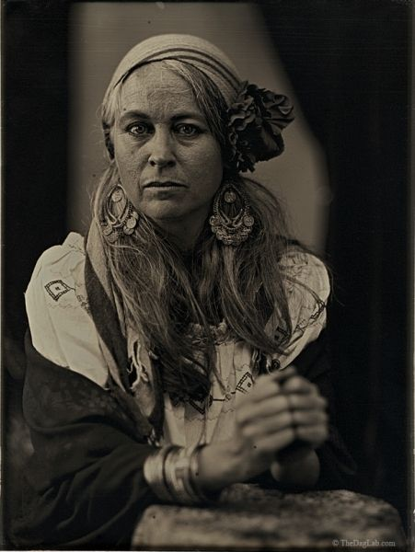
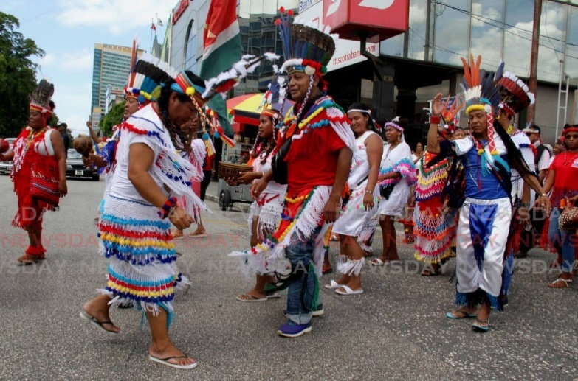
e
f
d

Which picture do you think best shows something in a positive light?
How do you think the people in pictures ‘c’ and ‘d’ feel?
What do you think picture ‘b’ illustrates?
What do you think picture ‘a’ illustrates?
From the pictures, what can you deduce about people who are different?

Film (1)
From 0:00 to 3:10

Task 1
Watch the film, listen to the speaker, read the subtitles.
Answer these questions.
- Where is the museum?
- When was it started?
- What is ‘Don’t forget’ in the Roma language?
- How many Roma are estimated to have been killed by Nazis and fascists?

Task 2
In groups of three, check your answers.
What did you find interesting in the film?
What did you already know?
What didn’t you know?

Film (2)
From 9:18 to 12:00

Task 1
What do you know about these places, people and dates in connection with World War 2?
Chelmno Auschwitz-Birkenau Warsaw ghetto Łódż ghetto
Partisans 1941 1942

Watch the film. Choose the correct answer.
- The first Roma death camp was at Chelmno / Aushwitz.
- 3,000 / 30,000 were killed in a single, murderous action.
- A Roma quarter was created in the Warsaw ghetto / Łódż ghetto.
- The victims were gassed and cremated / buried in the woods.

Task 2
In groups of three, check your answers.
What did you find interesting in the film?
What did you already know?
What didn’t you know?

Film (3)
From 26:13 to 30:03

Task 1
Watch the film, listen to the speaker, read the subtitles.
Answer these questions.
- Where is the name of the museum’s project?
- When does the book contain?
- What does the map show?
- Where is Jasenovac?
- How many people died at Jasenovac?

Task 2
In groups of three, check your answers.
What did you find interesting in the film?
What did you already know?
What didn’t you know?

10. Quiz

Match the questions with the answers.
- Who are the Roma people, commonly known as “Gypsies”?
- What negative stereotypes were associated with the Roma?
- How did non-Roma populations attempt to assimilate or eliminate the Roma?
- What was the tragic event during World War II that affected the Roma?
- What was the significance of the 1933 law for the Prevention of Hereditarily Diseased Offspring?
- What term do the Roma use to refer to the Holocaust?
- How did the perception of Roma change under Nazi racial ideology?

- The Holocaust led to the systematic persecution and murder of Roma. Approximately 250,000 to 500,000 Roma people were killed—an event they call the “Porajmos.”
- The Roma are a group of people who migrated from northern India to Europe over centuries. They include tribes like the Sinti and Roma, collectively referred to as “Gypsies.”
- The term “Gypsies” carried negative connotations due to the false belief that they originated from Egypt. Stereotypes included being nomadic, having dark skin, and speaking the Romani language.
- Efforts included stealing Roma children, outlawing their customs and language, and forcing them into settled lifestyles. Some laws even allowed the killing of Roma individuals.
- This law allowed for the sterilization of Roma individuals, contributing to their suffering during the Holocaust.
- Initially, Roma were not specifically targeted as a threat to the Aryan race. However, negative stereotypes became intrinsically tied to their racial identity, leading to their systematic slaughter.
- The Roma call the Holocaust the “Porajmos,” which means the “Devouring.”

11. Lesson round up - Discussion

- What is interesting to you about Roma life?
- What is interesting to you about Roma culture?
- Do you see or hear about Roma in the media?
- How is the subject of the Holocaust viewed in your country?
- What is being done in your country to promote tolerance to people who are different?
- What kinds of museums and memorials connected to the Second World War in your country?
- Do you think the world has become a better place since 1945?
- What happened to the Roma after the war in Poland?
- Before this lesson, what did you know about the Roma, gypsies, and the Holocaust?
- What changes would you like to see in your country in the way people treat each other?
- What causes ideologies like fascism and Nazism to become more popular in a society?
- Do international organisations and ideas have an influence on you or on people in your country?

12. Lesson round up - Review vocabulary

- Make a list of five words from the lesson.
- Test your partner on the words.
- Choose two key words from the lesson
- Which one point will you take away from the lesson?

Answers

1.
Roma cygan podróżników tradycja
stereotypy dyskryminacja prześladowania koczowniczy
osiedli Dziedzictwo Folklor Kultura
czystka zagłada getto przetrwać

3.
desire (2) slogan (4) oppression (5) ideology (6) minority (1) folklore (3)
4.

noun | verb | adjective | adverb
discrimination | discriminate | discriminatory
Stereotype | stereotype | stereotypical | stereotypically
ghetto | ghettoize | Ghettoised  ghettoising
nomad | nomadize | Nomadic  nomadized | nomadically

- The stereotypical portrayal of certain groups as nomadically inclined has led to discriminatory treatment in some societies.
- The discriminatory policies of the past have ghettoized entire communities, perpetuating stereotypes and limiting opportunities for many individuals.
- Some people make stereotypical assumptions about nomadically-inclined groups without understanding the cultural richness and diversity within these communities.
- It's important to challenge discriminatory attitudes and behaviors to create a more inclusive and equitable society for all.

5.

purge – which word is not a synonym
cleanse purify clear hoard
settlement - which two words are not synonyms
colony conflict village agreement community
survivor - which three words are not synonyms
casualty victim fighter perisher
folklore - which two words are not synonyms
mythology physics legend tradition book

6
Many answers possible

7
- Where is the museum? (Tarnow)
- When was it started? (1990)
- What is ‘Don’t forget’ in the Roma language? (Nabister)
- How many Roma are estimated to have been killed by Nazis and fascists? (500,000)
8
- The first Roma death camp was at Chelmno.
- 3,000 were killed in a single, murderous action.
- A Roma quarter was created in the Łódż ghetto.
- The victims were buried in the woods.
9
- Where is the name of the museum’s project? (Nabister)
- When does the book contain? (An inventory of 250 sites connected to Roma martyrdom)
- What does the map show? (Deportation and evacuation sites)
- Where is Jasenovac? (Yugoslavia, Croatia)
- How many people died at Jasenovac? (estimated 700,000)

10.
1B 2C 3D 4A 5E 6G 7F

