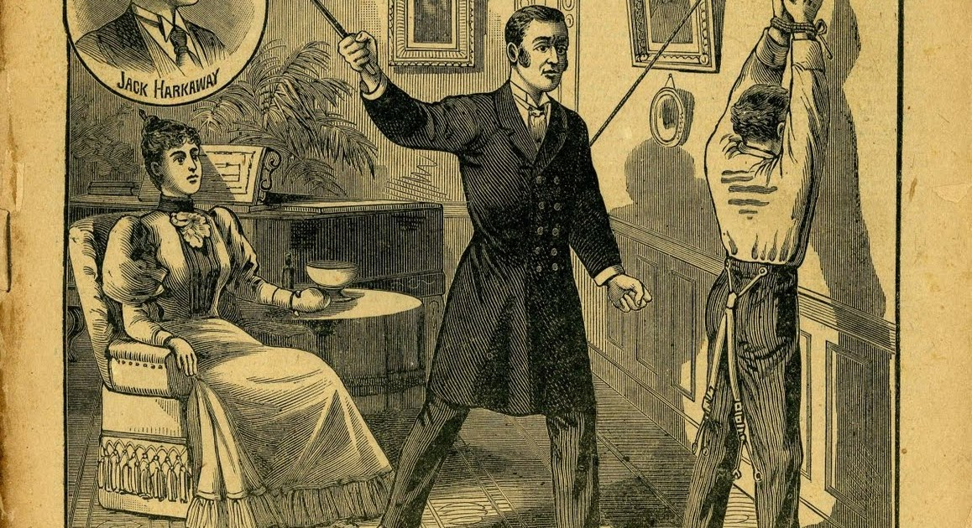

**The family model and what it produces**

Table of Contents

1. Vocabulary for this lesson 3

2. Warm-up questions 4

3. Vocabulary (1) 5

4. Vocabulary (2) 6

5. Vocabulary (3) 7

6. Picture task 8

7. Film (1) 9

8. Film (2) 10

9. Multiple choice quiz 11

10. Lesson round up - Discussion 12

11. Lesson round up - Review vocabulary 13

Answers 14

## 1. Vocabulary for this lesson

behaviour to bring up discipline

punishment to beat respect

to abuse feminine minor

shy to break someone adulthood

How do you say these words in your language?

Test your partner on the words

e.g. can you give me an example of a sentence with the words ‘bring up’ in it?

e.g. What kind of ‘behaviour’ would you say is ’feminine’?

## 2. Warm-up questions

What does a typical Polish family look like?

Are there different versions?

What should communication between parents and children look like?

In your experience, do parents listen to their children – and do children listen to their parents?

How do we learn what is right and wrong?

How important is discipline in family life?

How free should children be?

What are the limits of freedom – where can they be found?

What do you understand by the idea of personal responsibility?

What things are you responsible for in life?

## 3. Vocabulary (1)

Match the definition with the word

corporal punishment abuse freedom

responsible ethical

1. relating to [beliefs](https://www.collinsdictionary.com/dictionary/english/belief) about right and [wrong](https://www.collinsdictionary.com/dictionary/english/wrong)
2. able to answer for one's conduct and obligations
3. physical maltreatment
4. the absence of necessity, coercion, or constraint in choice or action
5. discipline that involves hitting someone

## 4. Vocabulary (2)

Compete the table with the word forms

|  |  |  |  |
| --- | --- | --- | --- |
| noun | verb | adjective | adverb |
| discipline  disciple | ___________ | disciplined  undisciplined  disciplinable |  |
| ___________  punisher | punish | punishing  punished  punishable | punishingly |
| abuse  abuser | abuse | abusive  abused | ___________ |
| ___________  adulthood |  | adult | adultly |

Use the words to complete the sentences.

1. The ___________ for adults are generally harsher than for children.
2. You can learn to play guitar if you are ___________. It is easier for children and more difficult in ___________.

## 5. Vocabulary (3)

Collocations and synonyms – find the odd one out.

**punishment** – which collocations are correct

harsh light handsome innovative

**free** - which synonyms are correct

bound liberated liberal without charge

**ethical** - which collocations are correct

person decision dog state

**minor** - which synonyms are correct

teenager baby pensioner prince

## 6. Picture task

Match the words with the pictures – more than one answer is possible sometimes.

single parent family same sex family multi-generational family

‘normal’ family happiness and joy close

senior citizens offspring baby

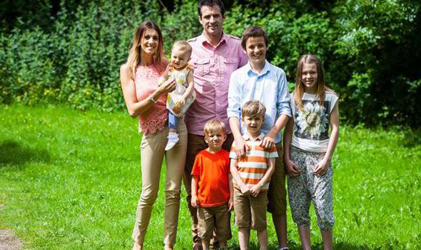

A 

B



C

DD

Who decides what a nation’s ‘traditional’ family is and what sort of family model is ‘normal’ nowadays?

How does the model vary between countries?

Generally, what makes young children happy?

In terms of family life, what makes teenagers happy?

Is there any difference in what a mother teaches a child, and what a father teaches a child?

## 7. Film (1)

**Task 1**

Do you know the answers to the questions? Work in groups of three and see if you can answer the questions.

* What was the Prussian model of raising kids?
* How did they achieve it?
* What were the black textbooks?
* What was the result of all of this?
* For what reasons were children beaten?
* What were the white ribbons?
* What was the role of a child do you think?

Watch the film, listen to the speaker, read the subtitles.

Try to find the answers to the questions.

**Task 2**

In the same groups of three, check your answers.

What did you find interesting in the film?

What did you already know?

What didn’t you know?

## 8. Film (2)

**Task 1**

Do you know the answers to the questions? Work in groups of three and see if you can answer the questions.

* How was the ideal man supposed to look?
* What duties are mentioned?
* How were cadets treated?
* How did architecture influence those who were surrounded by it?
* What was the opinion and role of women?
* How was the role of caring and the career viewed?
* How were the disabled viewed?

Watch the film, listen to the speaker, read the subtitles.

Try to find the answers to the questions.

**Task 2**

In the same groups of three, check your answers.

What did you find interesting in the film?

What did you already know?

What didn’t you know?

## 9. Multiple choice quiz

**What is the average age for children to leave home in Poland?**

**24.1 21.4 26.6**

**What is the average age for children to leave home in Denmark?**

**17.3 21.4 19.9**

**In 2011, what percentage of UK parents supported corporal punishment in schools?**

**23% 49% 74%**

**‘The child’s right to respect’ is a work by whom?**

**Mahatma Ghandi Bill Clinton Janusz Korczak**

**What is the most common age of criminal responsibility in Europe?**

**12 14 16**

**What are the ages for criminal responsibility (‘severe crimes’ and ‘standard’ crimes) in Poland?**

**12 / 16 14 / 18 15 / 18**

**Which is the most common form of corporal punishment in Uganda?**

**cane whip belt**

## 10. Lesson round up - Discussion

1. What is your opinion of corporal punishment?
2. Are there times when parents should be allowed to use corporal punishment?
3. Should corporal punishment be forbidden in every country?
4. What is the best way to educate a child in terms of ethics?
5. Do aggressive and violent parents produce aggressive and violent children?
6. What role does the state play in the moral education of children?
7. Is it ever right for children to hit their parents?
8. Is it ever right to hit an animal?
9. Should boys and girls be treated identically in the family?
10. How important is talking within families?
11. How important is listening?

## 11. Lesson round up - Review vocabulary

1. Make a list of five words from the lesson.
2. Test your partner on the words.
3. Choose two key words from the lesson
4. Which one point will you take away from the lesson?

## Answers

1.

zachowanie wychować się dyscyplina

kara pobić szacunek

wykorzystywać kobiecy nieletnie

nieśmiały złamać kogoś dorosłość

3.

1 ethical, 2 responsible , 3 abuse, 4 freedom, 5 corporal punishment

4.

Compete the table with the word forms

|  |  |  |  |
| --- | --- | --- | --- |
| noun | verb | adjective | adverb |
| discipline  disciple | discipline | disciplined  undisciplined  disciplinable |  |
| punishment  punisher | punish | punishing  punished  punishable | punishingly |
| abuse  abuser | abuse | abusive  abused | abusively |
| adult  adulthood |  | adult | adultly |

Use the words to complete the sentences.

1. The punishments for adults are generally harsher than for children.
2. You can learn to play guitar if you are disciplined. It is easier for children and more difficult in adulthood.

**5.**

punishment – which collocations are correct

harsh light innovative

free - which synonyms are correct

liberated liberal without charge

ethical - which collocations are correct

person decision state

minor - which synonyms are correct

teenager baby

6.

single parent family C same sex family D multi-generational family B

‘normal’ family A happiness and joy A, B, C, D close A, B, C, D

senior citizens B offspring A, B, C, D baby A, D

9.

24.1 19.9 49% Janusz Korczak 14 15 / 18 cane