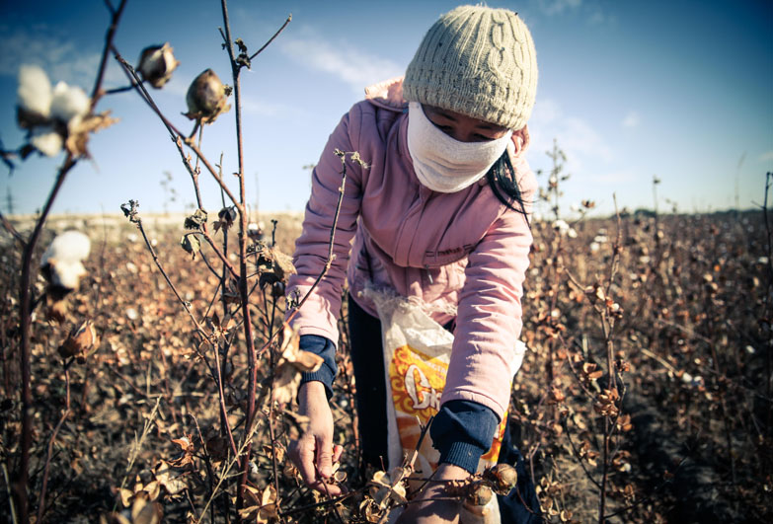

Labour and forced labour

Table of Contents
1. Vocabulary for this lesson 3
2. Warm-up questions 4
3. Vocabulary (1) 5
4. Vocabulary (2) 6
5. Vocabulary (3) 7
6. Picture task 8
7. Film (1) 9
8. Film (2) 10
9. True or false quiz 11
10. Lesson round up - Discussion 12
11. Lesson round up - Review vocabulary 13
Answers 14

1. Vocabulary for this lesson

to pick to make to force someone to do something
a plantation a field a call-centre
hourly output a factory a crop
a profit an hourly rate a salary

How do you say these words in your language?
Test your partner on the words
e.g. can you give me an example of a sentence with the word ‘crop’ in it?
e.g. have you ever ‘picked strawberries’?

2. Warm-up questions

Where do you buy your clothes from?
Where are they made?
Who makes them?
Why do they cost what they do?
What could you do with one dollar / four zloty?
What is the minimum wage in Poland?
How much money per month does one person in Poland need to live?

3. Vocabulary (1)

Match the definition with the word

poverty exploitation slavery
overtime wage

- the act of using someone unfairly for your own advantage:
- a particular amount of money that is paid, usually every week, to an employee
- extra payment for working after the usual time:
- the activity of legally owning other people who are forced to work for or obey you
- the condition of being extremely poor

4. Vocabulary (2)

Compete the table with the word forms
noun | verb | adjective | adverb
production  ___________ | produce | productive  producible | productively
labourer | ___________ | laboured  labouring
work  worker | work | _____________  workable
maker  make | make | home-made  hand-made

Use the words to complete the sentences.
- I have ___________ in three different places in my life – a factory, an office and a hospital.
- What ___________ of car do you drive? Where was it ___________? Is the ___________ ethical in its treatment of workers?

5. Vocabulary (3)

Collocations and synonyms – which are correct?

factory – which collocations are correct
to work in to open to shut down to turn
slave - which collocations are correct
to free to chain up to plough to update
work - which adverbs form correct collocations
hard hardly slowly underground
factory - which synonyms are correct
call centre plant mine mall

6. Picture task

Match the products with the pictures.
tea cotton hops information
leaves sugar cane strawberries soft fruit
t-shirts beer

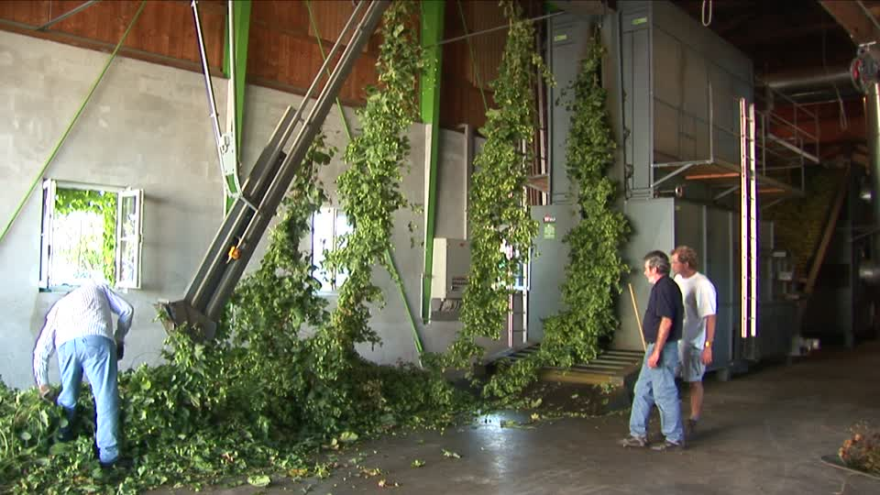
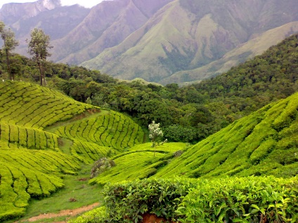
c
b
a


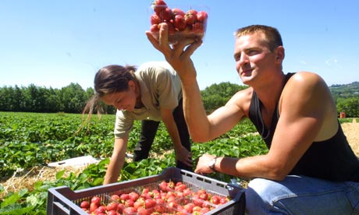
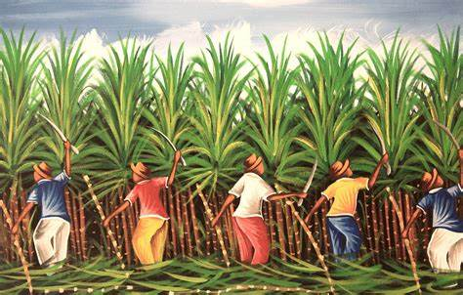
e
d

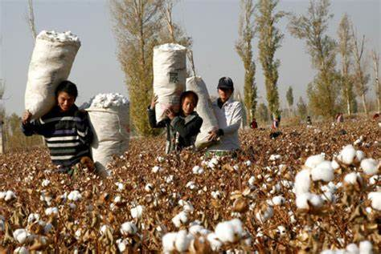
f

Where (countries / regions) do you think the crops are grown?
What are the working conditions in the places in the pictures like?
What are the workers in the places paid?
What do you think is a fair salary?
Who makes the profit from the products connected to the crops?

7. Film (1)

Task 1
Do you know the answers to the questions? Work in groups of three and see if you can answer the questions.
- What are the roots of forced labour?
- What happened in Egypt?
- What did the Age of Discovery produce?
- What was the role of sugar in forced labour?
- What came with industrialisation?
- When was slavery abolished in the US?
- How did forced labour work during World War 1?
Watch the film, listen to the speaker, read the subtitles.
Try to find the answers to the questions.

Task 2
In the same groups of three, check your answers.
What did you find interesting in the film?
What did you already know?
What didn’t you know?

8. Film (2)

Task 1
Do you know the answers to the questions? Work in groups of three and see if you can answer the questions.
- Do we have forced labour these days?
- How much?
- Who is subject to it?
- What do forced labourers produce?
- What role does poverty play?
- Which conditions are imposed on forced labourers?
- How do corporations treat the issue?
Watch the film, listen to the speaker, read the subtitles.
Try to find the answers to the questions.

Task 2
In the same groups of three, check your answers.
What did you find interesting in the film?
What did you already know?
What didn’t you know?

9. True or false quiz

- Eight million people were used as forced labour by the Third Reich during the Second World War.

- An average 18-kilo haul of tea by a tea picker brings in around $3.

- Two countries in the world have more than 1 million slaves in 2020.

- The minimum wage in the UK is lower if you are under 25

- 3.5 million people in Bangladesh are employed in the garment trade

- The average salary in Monaco is 283 times higher than in Congo

10. Lesson round up - Discussion

- What is slavery?
- What is modern slavery?
- In what way does it exist in your country / the EU?
- What should the punishment for slavery be?
- Where does our tea, coffee and rice come from?
- How is it produced?
- Who makes money from it?
- What do you know about strawberry and apple crops and how they are produced?
- Who protects workers’ rights in Poland?
- What are the basic rights every worker should have?
- Is there any justification for working more than eight hours per day?

11. Lesson round up - Review vocabulary

- Make a list of five words from the lesson.
- Test your partner on the words.
- Choose two key words from the lesson
- Which one point will you take away from the lesson?

Answers

1.
Zebrać zrobić zmusić kogoś do zrobienia czegoś
Plantacja pole call-center
wydajność godzinowa fabryka roślina uprawna
zysk stawka godzinowa pensja

3.
Poverty 5 exploitation 1 slavery 4 overtime 3 wage 2

4.
noun | verb | adjective | adverb
production  producer | produce | productive  producible | productively
labourer | labour | laboured  labouring
work  worker | work | working  workable
maker  make | make | home-made  hand-made

- I have worked in three different places in my life – a factory, an office and a hospital.
- What make of car do you drive? Where was it produced? Is the producer ethical in its treatment of workers?

5.
factory – to work in to open to shut down
slave - to free to chain up
work - hard slowly underground
factory - plant

6
tea a cotton f hops b information c
leaves a sugar cane d strawberries e soft fruit e
t-shirts f beer b

9.
- False – it was 13.5 million
- True
- False – it is 6
- True
- True
- False – it is 260 times higher

